**Order Entry Query Results and Table Contents**

Edward Galligan III

Colorado State University – Global Campus

MIS407 – Database Concepts

Dr. Kadri Brogi

February 14, 2021

**Order Entry Query Results and Table Contents**

Figure 1 and Figure 2 below show the query results and table contents, respectively, for the Customer table.

**Figure 1**

*Customer table query results*

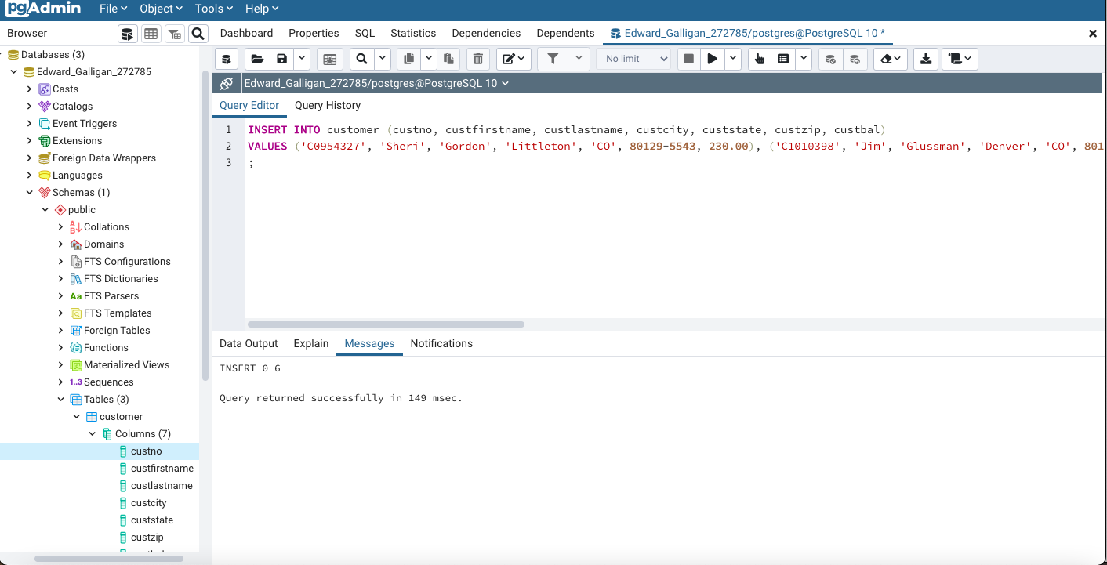

**Figure 2**

*Customer table contents*

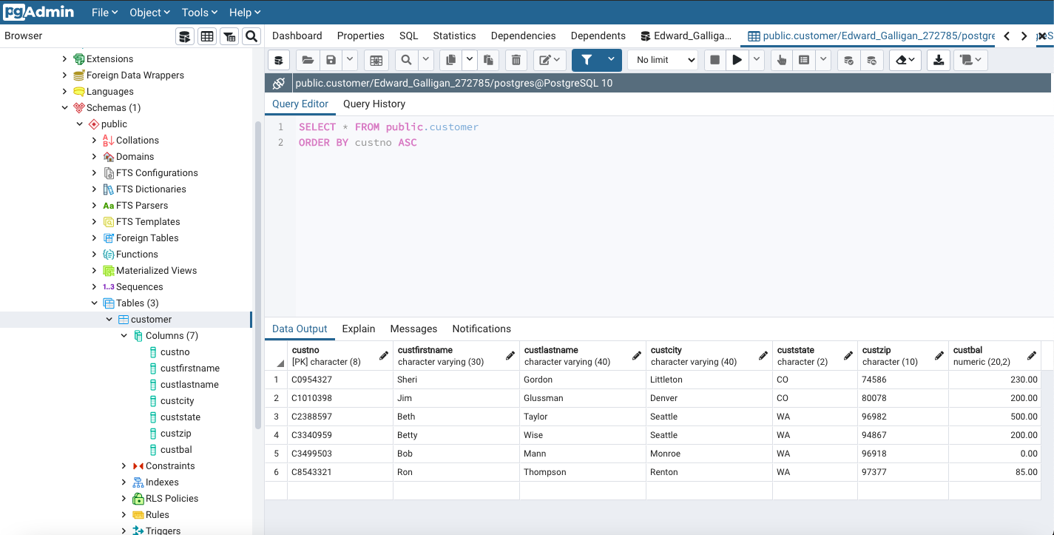

Figure 3 and Figure 4 below show the query results and table contents, respectively, for the Employee table.

**Figure 3**

*Employee table query results*

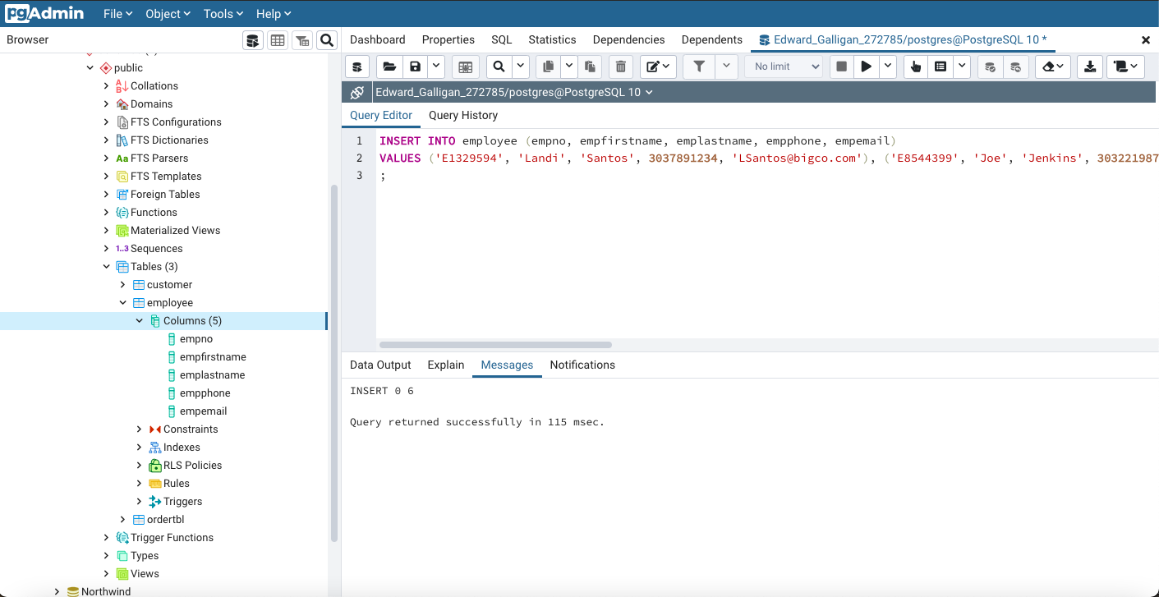

**Figure 4**

*Employee table contents*

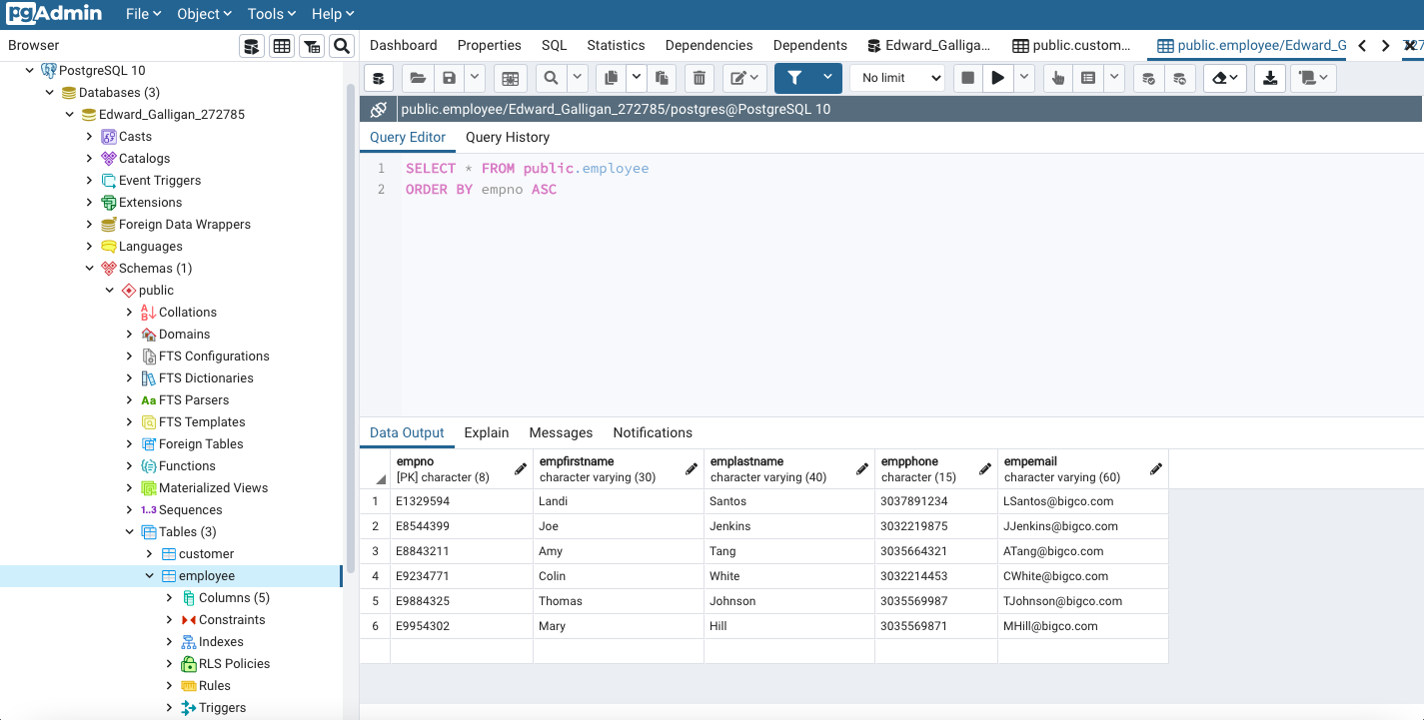

Figure 5 and Figure 6 below show the query results and table contents, respectively, for the OrderTbl table.

**Figure 5**

*OrderTbl query results*

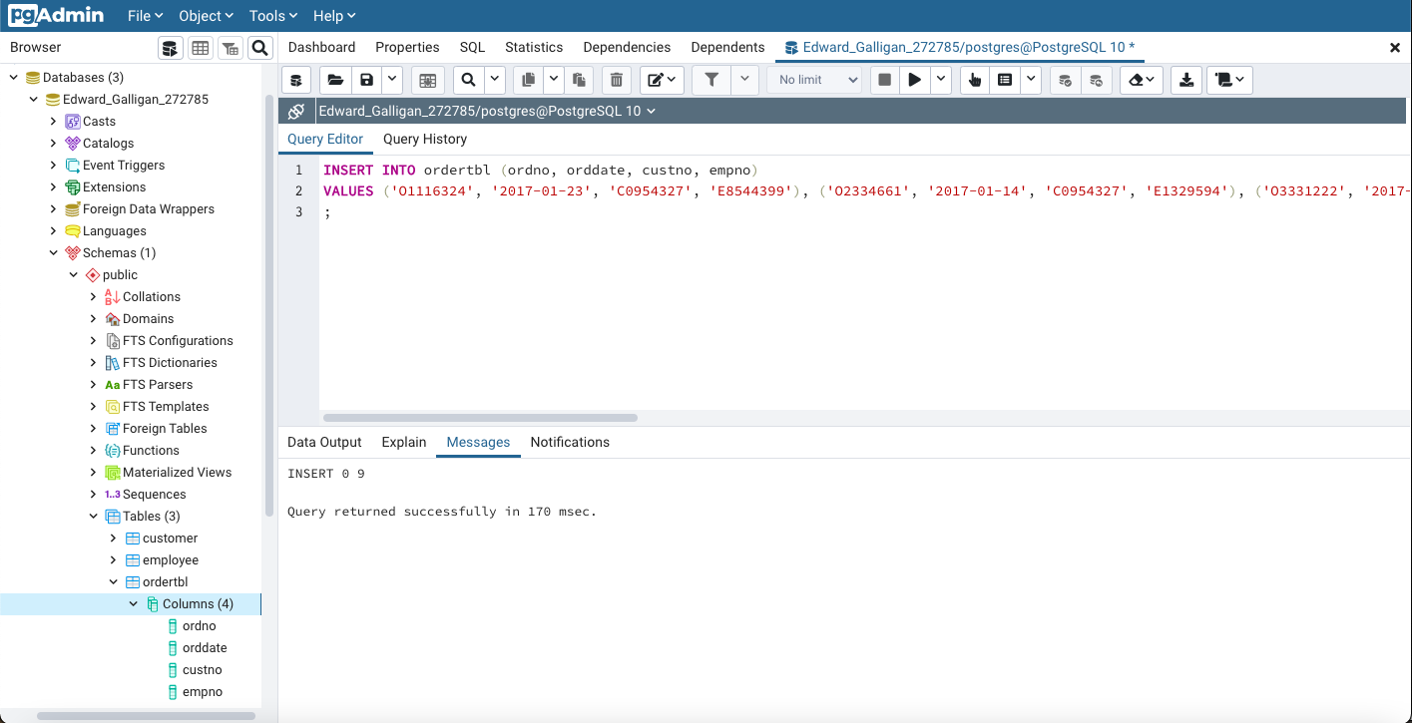

**Figure 6**

*OrderTbl table contents*

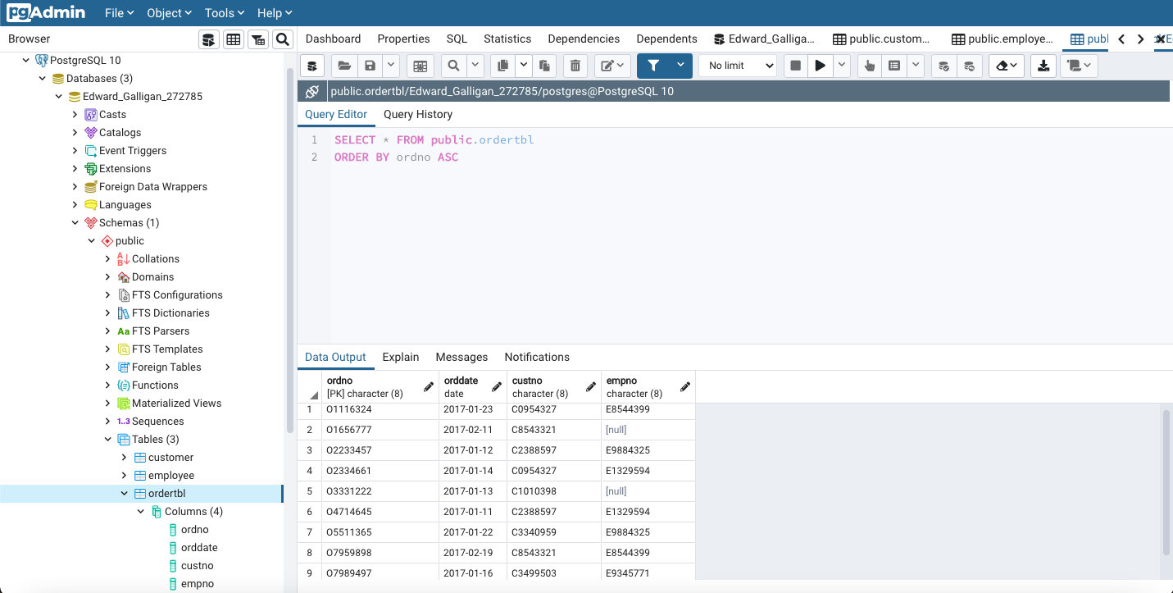

**Key Findings**

One key finding from this assignment was the use of INSERT statements to insert new data into database tables (Juba & Volkov, 2017, p. 185). This is done by, as seen in Figure 1, Figure 3, and Figure 5, by naming the table to insert new data into after the INSERT INTO keywords, followed by the fields to be updated, and the list of values to insert after the VALUES keyword (Juba & Volkov, 2017, p. 185). Data that is entered after the VALUES keyword will be inserted in the order that they are entered (Juba & Volkov, 2017, p. 185).

**References**

Juba, S. & Volkov, A. (2017). *Learning PostgreSQL 10* (2nd Ed.). Birmingham B3 2PB, UK: PackT Publishing.